ReInsurance XLRe EMT Access and Certificates details Document

Document Details
Version | Date | Author | Description
1.0 |  | Saha Priyanka | Initial Draft
1.1 |  | Viji Sugumaran | Final Version
1.2
1.3
1.4

Contact Details:
Roles and Responsibilities
Team Name | Team Member | Role | Mobile | Email
Risk Consulting Site Forward | Ambuj Kumar | Application Owner |  | ambuj.kumar@axaxl.com
DevOps Engineer | Ambati, Hemanth Kumar | DevOps |  | hemanthkumar.ambati@contractor.axaxl.com
SDC/AMS |  | Support
Developer | Saha Priyanka | Developer |  | priyanka.saha@contractor.axaxl.com

Contents
Contact Details: 1
CPP Access 2
Repository Access 4
Harness and Azure DevOps access 5
Certificate Details 6
DB Jump Server Access Details 7
AD group access details for NPD and PPD databases 9
GitHub Access 9

CPP Access
To get the CPP Access for the XLRe EMT application, please follow the steps below:
- Identify the CPP access required and select roles:
  - Developer Access: This access allow you to develop the application with viewing the resources on the Azure Portal. Below roles are required for the developer access:
    - Subscription-viewer
    - Application-contributor-npd
    - Application-viewer-npd
  - Contributor: This access gives you full control over the cloud resources and feature to add new cloud services as required. Below roles are required for the contributor access:
    - Subscription-contributor
    - Subscription-viewer
    - Application-contributor-npd
    - Application-viewer-npd
- With the above roles, users can get the access to the lower environments, if any user or contributor need higher environment access, with above roles add below additional roles as required:
  - Application-contributor-ppd
  - Application-viewer-ppd
  - Application-contributor-prd
  - Application-viewer-prd
- Connect with the Application Owner Ambuj Kumar
- Inform application owner that you need to be onboarded to the CPP with the selected roles and provide your UPN ID.
- Application owner has capability to add/update the users and select the proper role accordingly.
- Once, Application owner added you to the CPP, you can visit the CPP portal: https://portal.axaxl-cloud.com/ and can see XLRe EMT Application as below:
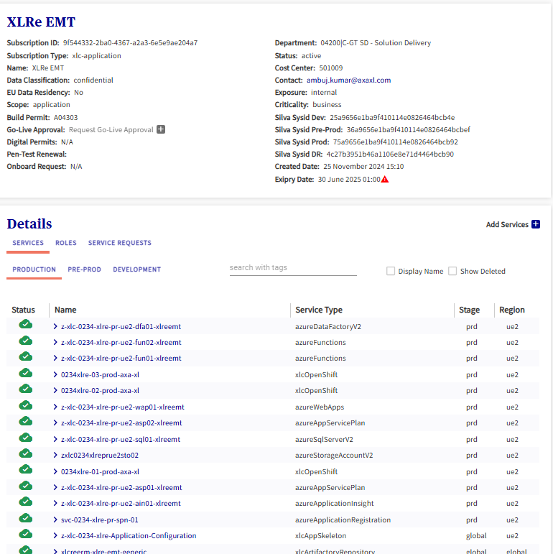

Repository Access
As EMT is moved to the cloud, its code repository is also moved from the TFS to the Azure DevOps, to get the access for the repository please follow the steps below:
- Open Silva Portal: Home Silva - Silva Portal SSP
- Click on Request Something to submit the new Request:( Request something - Silva Portal SSP)
- Search and select for : Application-specific Requests - Azure DevOps Services
- Fill up the form as shown in the below image: 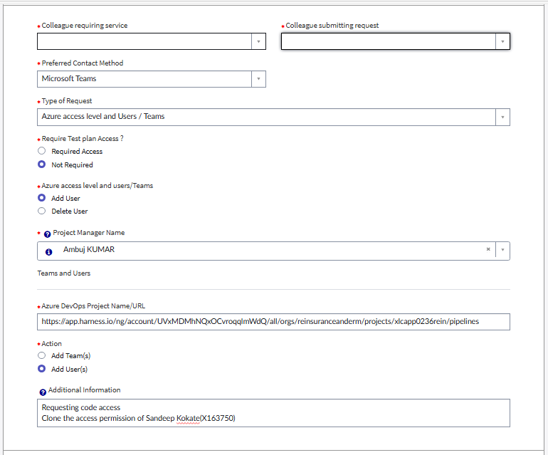
- Select the Project Manager as Ambuj Kumar
- Enter the Azure DevOps Project URL as: Harness
- Add the additional information as: Requesting for Full access of the given repository to carry out the development work for the EMT Application.
- Submit the request.
- Once request is approved, you should be accessible to the Repository URL mentioned above.

Harness and Azure DevOps access
Once user is added to the CPP as subscription-contributor and authorized to access the Azure DevOps with the Silva request, he/she will get Harness access by default to create/update or run the CI CD pipelines.
While raising the Silva request for Azure DevOps, specifically mention the Pipeline Read/Write access is required for DevOps Activity.
If user faces any issues to login the Harness, connect with the Silva Support Team.

Please Note:
If you are not a subscription-contributor and you want access to the Harness as DevOps person to modify/Create or update Pipelines, you need to connect with the CI/CD team to raise additional access request.

Certificate Details
For Azure Web Apps, when DNS request is raised, the Certificate is mapped by the CPP team itself and it’s setup with 1 years of expiry, following are the certificates mapped along with the DNS by the CPP Team.

DNS Name | Certificate Name | Certificate Expiry Date
xpo-dev.axaxl-cloud.com | 0234xlre-01-dev-axa-xl | 11/17/2026
xpo-coreapi-dev.axaxl-cloud.com | 0234xlre-01-dev-axa-xl | 11/17/2026
xpo-mappingapi-dev.axaxl-cloud.com | z-xlc-0234-xlre-dv-ue2-wap01-xlreemt | 11/17/2026
xpo-sit.axaxl-cloud.com | 0234xlre-04-dev-axa-xl | 11/17/2026
xpo-coreapi-sit.axaxl-cloud.com | 0234xlre-04-dev-axa-xl | 11/17/2026
xpo-mappingapi-sit.axaxl-cloud.com | z-xlc-0234-xlre-dv-ue2-wap02-xlreemt | 11/17/2026
xpo-uat.axaxl-cloud.com | 0234xlre-04-preprod-axa-xl | 11/17/2026
xpo-coreapi-uat.axaxl-cloud.com | 0234xlre-04-preprod-axa-xl | 11/17/2026
xpo-mappingapi-uat.axaxl-cloud.com | z-xlc-0234-xlre-pp-ue2-wap01-xlreemt.azurewebsites.net | 11/17/2026
xpo.axaxl-cloud.com | 0234xlre-01-prod-axa-xl | 11/17/2026
xpo-coreapi.axaxl-cloud.com | 0234xlre-01-prod-axa-xl | 11/17/2026
xpo-mappingapi.axaxl-cloud.com | z-xlc-0234-xlre-pr-ue2-wap01-xlreemt.azurewebsites.net | 11/17/2026

DB Jump Server Access Details
XLRe EMT Jump Server is already available to connect the Higher environments XLRe EMT Databases. Please use following steps to connect DB:
- Login to the Jump Server: XLCMGT412633DV.R02.XLGS.LOCAL
- Open SQL Server Management Studio.
- Get the Database Server name and Database name details from the confluence page : MttC XLReEMT - Technical Design - RADAR - Confluence by AXA GO or get the details from the Azure Portal: SQL servers - Microsoft Azure
- Once you are ready with the DB Server name and the DB Name, use the details in the Connect to Server Screen in SSMS as example below for Production access:
  - Server name: z-xlc-0234-xlre-dv-ue2-sql01-xlreemt.database.windows.net
  - Database Name: z-xlc-0234-xlre-dv-ue2-sdb01-xlreemt
- Use the Authentication as “Microsoft Entra Default” and enter your UPN ID.
- Or you can use “Microsoft Entra Password” and enter UPN ID and your password.
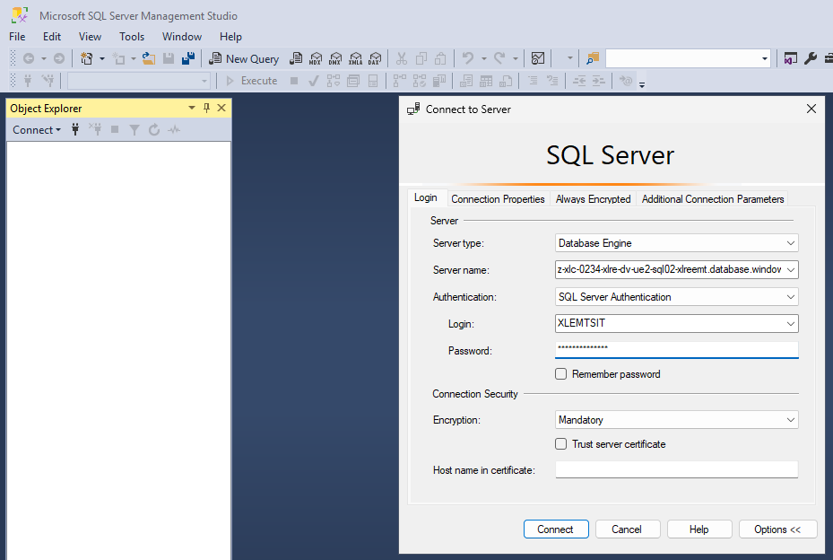
- In the Connection Properties Tab, enter the Database name as below:
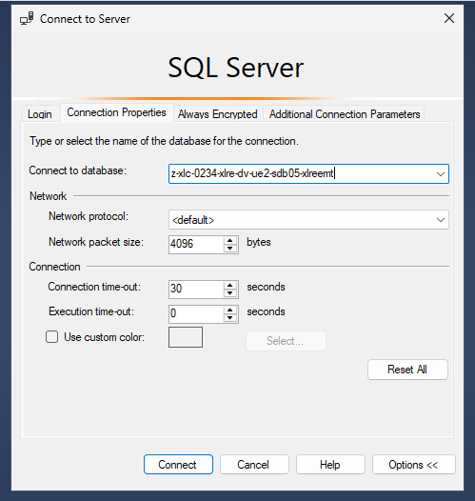
- Click on Connect.
- You should able to connect to the Database and execute select queries.

AD group access details for NPD and PPD databases
To access the databases with your AXA-XL Credential you should be part of the AD Group, for XLRe EMT, following AD groups are created:

- R02 AD Group: For Application Development and support users
EMT_ppd_app, EMT_ppd_admin_app
EMT_ppd_app, EMT_ppd_admin_app
EMT_prd_app, EMT_prd_admin_app
EMT_prd_app, EMT_prd_admin_app
- Azure AD Groups: For Application Development and support users
AZU - AC – DBX -0234-xlre-pp-ue2-sql01-Developer- Reader
AZU - AC – DBX -0234-xlre-pr-ue2-sql01-Developer- Reader
AZU - AC – DBX -0234-xlre-dv-ue2-sql01-Developer- Reader
AZU - AC – DBX -0234-xlre-dv-ue2-sql02-Developer- Reader
AZU AC - DBX - 0234-xlre-dv-ue2-sdb01-xlreemt -Writer
AZU AC - DBX - 0234-xlre-dv-ue2-sdb02-xlreemt -Writer
AZU AC - DBX - 0234-xlre-dv-ue2-sdb05-xlreemt -Writer
AZU AC - DBX - 0234-xlre-dv-ue2-sdb06-xlreemt -Writer

To add new User to the above AD Group please raise Silva Request: AD Group - Add or Delete Users
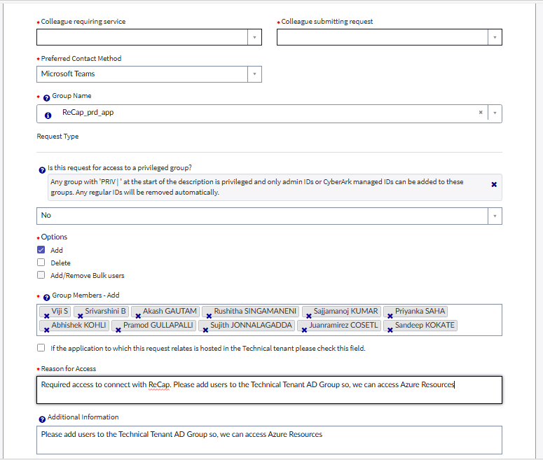

Please make sure you are added into the Technical Tenant AD Group, so you can access the Azure Resources with your AXA ID.
GitHub Access
GitHub repository contains the following structure, we have created main branch for this:
xlc-portfolio-reinsurance-and-erm/xlc-app-xlre_emt
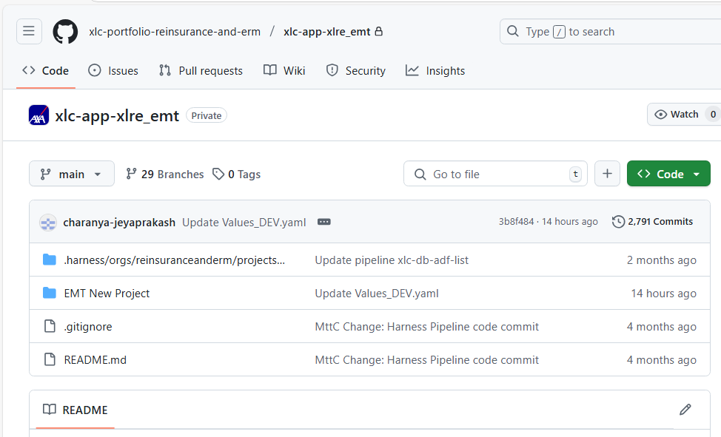

GitHub access is by default available when you are enrolled in the CPP with following permissions:
Subscription-viewer
Application-contributor-npd
Application-viewer-npd.

